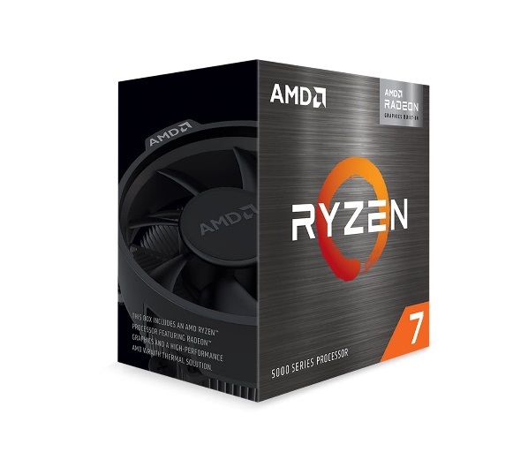

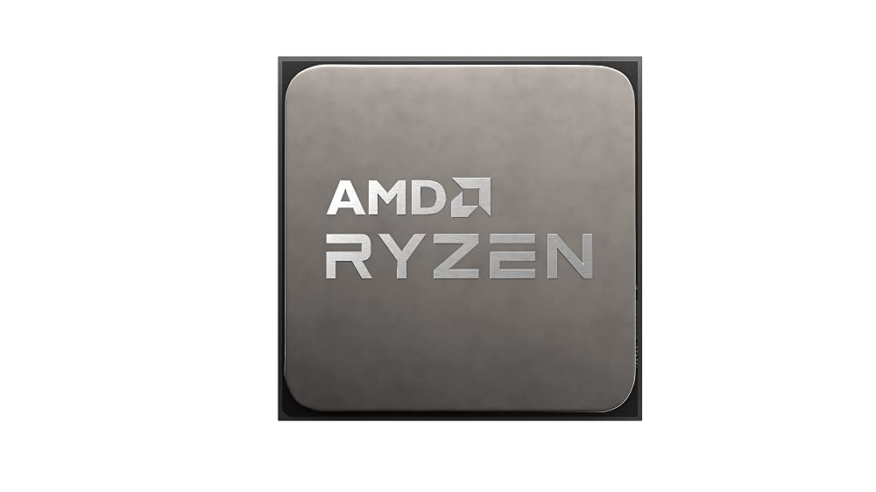

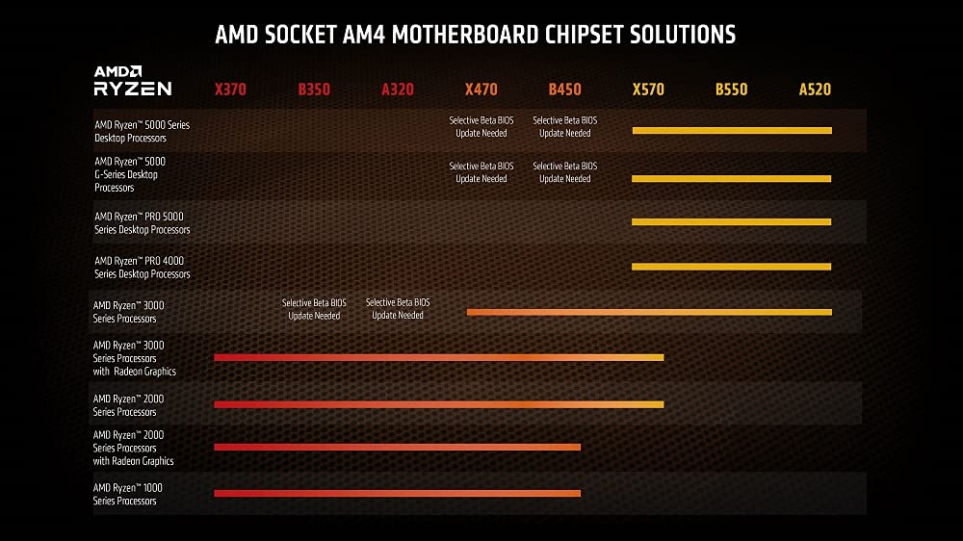

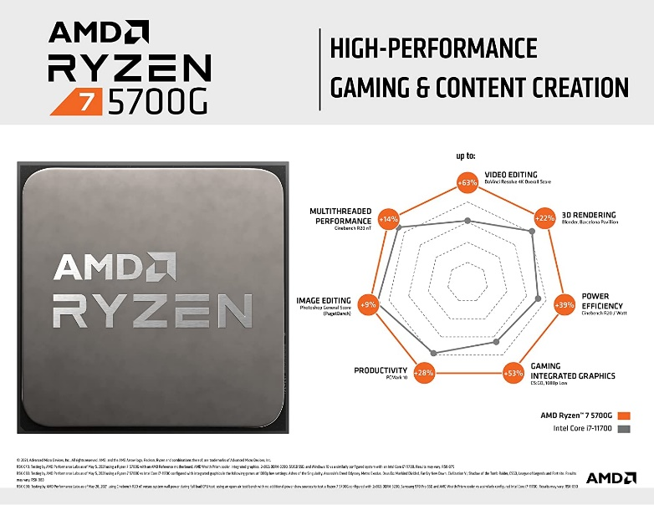

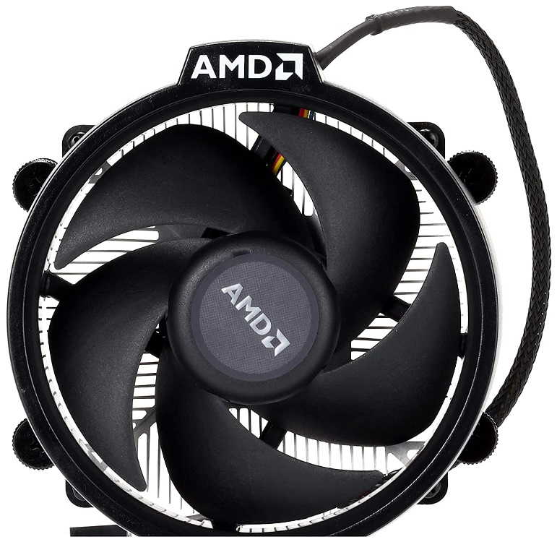

AMD Ryzen™ 7 5700G Desktop Processor (8-core/16-thread, 20MB Cache, up to 4.6 GHz max Boost) with Radeon™ Graphics

|  |  |
| --- | --- |
| M.R.P.: | ₹47,500.00 |
| Deal Price: | ₹27,799.00   |  |  | | --- | --- | | Brand | AMD | | CPU Manufacturer | AMD | | CPU Model | Ryzen 5 | | CPU Speed | 3800 MHz | | CPU Socket | Socket AM4 |   **About this item**   * 8 Cores & 16 Threads, 20 MB Cache * Base Clock: 3.8 GHz, Max Boost Clock: up to 4.6 GHz * Memory Support: DDR4 Upto 3200 MHz, Memory Channels: 2, TDP: 65W * Compatible with Motherboards based on 500 series chipset, Socket AM4 * Graphics: AMD Radeon Graphics, Included Heatsink Fan: Wraith Stealth * 3 Years Brand Warranty. For Technical Support : Please Contact : Tel: +91-80-67030050 (Mon-Fri: 09:00 - 17:00 IST); Expect Delayed Response due to ongoing COVID Crisis * For all performance-related issues in: AMD Processor: Please reach out via AMD brand home page > Drivers & Support > Customer Support  (Technical & Warranty help) > Contact Support > Online Service Request In case you are not satisfied the resolution provided by the above brands, please reach back to Amazon Customer service for next steps. |